DATE: 28.09.2018
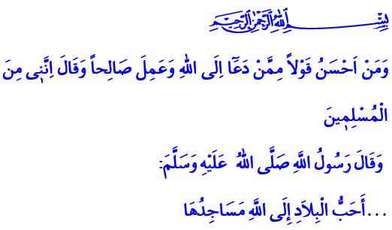
MOSQUES, AND LIVES DEDICATED IN SERVICE OF RELIGION
Jumu’ah Mubarak, Dear Brothers and Sisters!
The first thing done following the Hijrah to Madinah by our beloved Prophet (saw), who was sent as a mercy to the worlds, was to have a masjid built there. Right alongside this masjid, which we know by the name of al-Masjid al-Nabawi, he (saw) had a canopy built for the lonely and poor companions to take shelter. Those companions who lived in the canopy called Suffah spent most of their time with the Messenger of Allah (saw) and learned Islam. One day our Prophet (saw) saw his companions sitting in two groups when he entered the masjid. In one group, some companions were reciting the Qur’an and praying. In the other group were sitting those companions who were learning and teaching. After watching them with eyes filled with love and mercy, our Prophet (saw) sat near those companions who were learning and teaching after saying, “Both of them are good. These people are reciting the Qur’an and supplicating to Allah, and if He wills He will give them, and if He wills He will withhold from them. And these people are learning and teaching. Verily I have been sent as a teacher.”
Honorable Muslims!
Masjids and mosques have been honorable places for us to worship Allah, and acquire knowledge and wisdom since the Asr al-Sa’adah (the Age of Bliss). Mosques which are the most favored places in the sight of Allah are sacred places in which we contemplate Lord (swt) and present our servitude, du’as, and invocations to Him (swt). Mosques unite the believing hearts without discrimination of language, color, race, rank or position; consolidate our unity; and represent our faith and independence. Their minarets are the symbol of oneness; their adhans are the foundation of shahadah; their mihrab, pulpit, and minbar are the voice of the right and truth; and their rows and ranks are the assurance of peace and trust.
Esteemed Believers!
People who carried out duties in mosques and served for the religion of Islam from their minbar, mihrab, and pulpit were deemed worthy by our ancestors to be called as “Hadamah al-Khayrat”, meaning “Servants of Goodness”.
Servants of goodness are people who devote their lives in service of religion. They are those people who work sincerely and seek only the countenance of Allah (swt) for the good they do. A mufti gives direction to the spiritual life in cities; a muadhdhin calls humanity to salvation with adhans; an imam leads the prayer in mihrabs; a wa’iz teaches the straight path of Islam from minbars and pulpits. A Qur’anic course teacher brings together our children with the Holy Qur’an and the exemplary life of the Prophet (saw), and is the beneficiary of the Prophetic compliment, “The best of you is he who learns the Qur’an and teaches it.”. They are those who try to become the beneficiary of our Lord’s (swt) glad tiding “And who is better in speech than one who invites to Allah and does righteousness and says, ‘Indeed, I am of the Muslims.’”
They are the ones who are with us at every stage of our lives. They are there to whisper the divine glad tiding of adhan and iqama in the ears of our newly born babies. They are there in the most memorable moments of our childhood, and provide guidance at our young ages when guidance is most needed. They are always there with their prayers when we leave for the military service, when we take a step to start a family, and eventually when we depart from this world for the eternal journey.
Honorable Believers!
Every year, the first week of October is celebrated as the Week of the Mosques and Religious Officials. This year, it will be celebrated with the theme of “Mosques, and Lives Dedicated in Service of Religion”, and the importance and place of mosques in our civilization and the exemplary people who have dedicated their lives in service of religion will be highlighted throughout the week. The support and sacrifices of our esteemed nation for the improvement of our mosques and Qur’anic courses will be remembered.
Esteemed Believers!
I would like to take this opportunity to pray Allah the Almighty (swt) for mercy for our deceased brother and sister religious officials, and for a healthy and peaceful life for the remaining ones, who all have put efforts, from the past to the present day, in the material and spiritual reconstruction of our mosques. May the Lord Almighty (swt) allow us to become a servant of goodness and provide good services for humanity.

Ibn Majah, Sunnah, 17.
Muslim, Masajid, 288.
Tirmidhi, Fadhail al-Qur’an, 15.
Fussilat, 41/33. General Directorate of Religious Services

